Functional Specification Document

PROJECT: MVP 2 Farming Engagement Hub
EPIC: Farmer Segmentation
Functionality: Segmentation Management
User Story ID: PA-SEG-006
Functional Specification For: (X) Web Application ( ) Mobile Application
Portal: Back Office PA (Web)
Prototype: BAT - Agri 360 — Figma (segmentation flows)

Contents
- 1. Revision History
- 2. Sign-off
- 3. Process Specification
- 4. User Interface & User Experience
- 5. Policy & Regulatory Requirements
- 6. Technical Requirements
- 7. Positive & Negative Testing

1. Revision History
Date | Name | Change | Version
26/05/2026 | Matheus Kist | Initial document draft | 1.0

2. Sign-off
All screens described in this document are operated by the Backoffice PA User within the Back Office PA portal.
Date | Name | Role

3. Process Specification
- What? Maintain official farmer segmentation per crop season; manual segment override with approval.
- Who? Backoffice PA User; segment changes require Approval Workflow approvers.
- When? After official segmentation exists for a season.
- Where? Segmentation Management screen (Web).
- Why? Controlled exceptions without full re-simulation.
- How? Select season, review grid, propose segment change, submit for approval.

3.2 Business rules
- Allowed segments: only those from the configuration that produced the official snapshot.
- Manual segment change does not recalculate scores (scores remain from last accepted simulation unless a new simulation is accepted).
- Farmer must have official segmentation for the season to change segment.
- Optional: block exclusive-only segments for non-exclusive farmers (same as simulation).

4. User Interface & User Experience

4.1 SCREEN 01: Segmentation Management (Web)
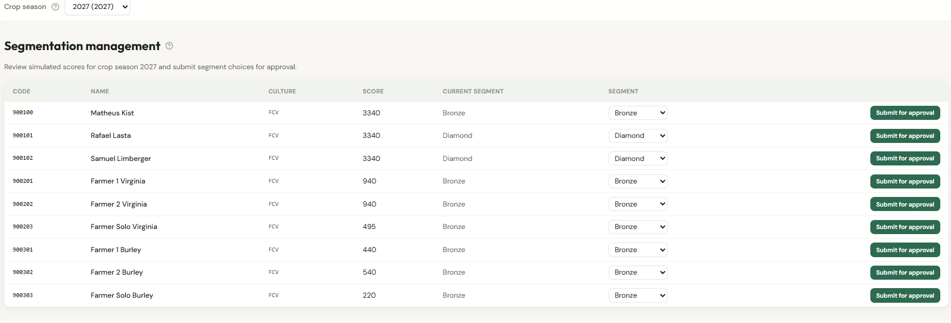
Figure 1 — Wireframe: segmentation management by crop season.

- Crop season selector.
- Grid: farmer code, name, culture type, total score, current segment, segment dropdown, Submit for approval.
- Dropdown lists only valid segments for that farmer's official configuration.
- Success message after approval completes; grid refreshes.

4.2 Approval Workflow
New Approval Configuration (example code: SEG_FARMER_SEGMENT_CHANGE):
- Trigger: Submit for approval on a row.
- Payload: farmer identity, season, current and proposed segment, total score, configuration name.
- On approve: persist new segment on official farmer segmentation.
- On reject: no change; notify requester.
- Recommended: mandatory reason comment on request.
- Approver must differ from submitter (configurable).

5. Policy & Regulatory Requirements
Manual tier changes affect discounts and farmer communication — full audit. Align approver matrix with simulation accept configuration.

6. Technical Requirements
- Reads official farmer segmentation and configuration segments.
- Approval Workflow invokes persistence on final approval.

7. Positive & Negative Testing
ID | Scenario | Expected result
T-01 | Approve segment change | New segment shown; scores unchanged.
T-02 | Invalid segment for configuration | Validation error at submit.
T-03 | No official segmentation | Cannot submit.
T-04 | Reject approval | Segment unchanged.
T-05 | User without Backoffice PA User role | No edit or submit.

